**AIM**

To write and execute a Prolog program that finds the sum of the first *N* natural numbers using recursion.

**ALGORITHM**

1. **Start** the program.
2. Define the **base case**:
   * If N = 1, then sum(1,1).
3. Define the **recursive case**:
   * If N > 1,
     + Compute N1 = N - 1.
     + Recursively find sum(N1, S1).
     + Compute S = S1 + N.
4. Query the program with the required value of N.
5. The Prolog interpreter will compute the sum and display the result.
6. **Stop**.

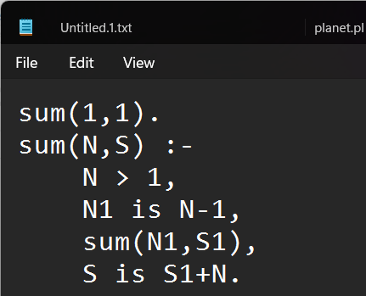

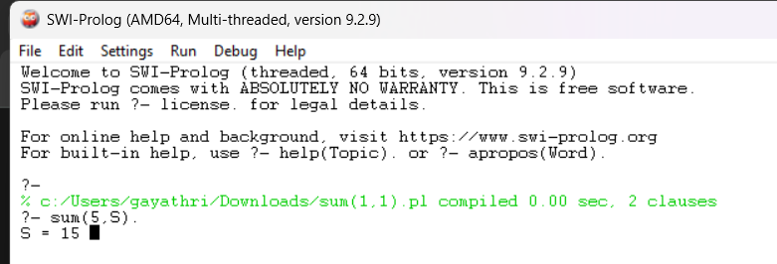

**Result:** The program calculates the sum of the first N natural numbers; for example, if N = 5, the sum is 15.